**Business Requirements Document**

**Project: eVal Implementation**

**BRD Title: General and Misc Items**

**BRD: #1**

**Development required by:**

***Washington State’s eVal Team***

**BACKGROUND**

This Business Requirement Document (BRD) is part of a set of business requirement documents that are part of the Seattle School District’s 2015 implementation of Washington State’s online evaluation tool, eVal. eVal is an online tool developed by the State to support teacher professional growth in alignment with Washington State’s mandates for TPEP (Teacher Principal Evaluation Process). The project goal is to successfully integrate this tool into the District’s TPEP activities, adhering to the District’s obligations of its CBA and to the spirit of the TPEP process which is aimed at fostering professional growth through collaborative, face-to-face discussions between teacher and evaluator.

BRDs related to eVal functionality have been submitted to the State’s eVal development team. BRDs related to back-office activities which require District development have been submitted to DOTs (the District’s development team). Where noted, several of these documents require review and collaboration from both teams.

*For further information, please see Excel file “eVal Seattle - Enhancements and BRD Index” which contains listing of each enhancement that has been approved for development and the related BRD and assigned development team.*

| Version No. | Date | Name | Description of Change |
| --- | --- | --- | --- |
| 1 | 10/31/14 | Donna Schmidt | Baseline; submitted to for review to eVal, DOTs and HR teams |
| 2 | 11/14/14 | Donna Schmidt | Added requirement 1.5 per SEA request |
| 3 | 11/19/14 | Donna Schmidt | Misc. word smithing per stakeholder review (no material changes); updated Review/Approval table to reflect current status |

# High Level Requirement Description

The set of requirements in this document addresses a variety of small enhancement requests related to eVal’s front-end UI (User Interface). This includes simple modifications to configuration settings within eVal such as the display of options that may be selected, internet compatibility specifications, and establishing “control switches” on eVal’s internal messaging panel.

# Business Objective

The requirements in this document will ensure a CBA-compliant experience for teachers and evaluators and will help ensure that the process is aligned with the spirit of professional growth fostered by collaborative face-to-face discussion supported by the District.

# Business processes impacted by the change

(All BRDs submitted to the eVal team impact TPEP activities as conducted via the eVal online tool)

# Requirement Details

|  |  |  |
| --- | --- | --- |
| REQ ID | Requirement | Purpose or expected outcome |
| 1.1 | Need the ability to set controls for enabling or disabling the manual and system-generated messaging function within eVal. | Regarding system-generated messages, the District is concerned that a teacher or evaluator may assume they are being notified by system-generated messages for any change that the other party makes to the system, when in fact each party could potentially make changes that do not generate a system message. This could lead to one of the parties entering information that the other party does not see in a timely manner, or not see at all. Additionally, the District has concerns on the amount of messages that could potentially be generated, and the challenge this could make for the evaluator to manage a new stream of email-like messages.  Regarding user-generated messages, the District is concerned that this functionality could enable an evaluator to rely too heavily on electronic communication (thereby defeating the goal of face-to-face communication) and/or that a teacher could mis-use this functionality in cases where the teacher/evaluation relationship is not functioning in a healthy manner.  Functionality should allow for a discretionary-based selection of ‘disable’ or ‘enable’ for either or both at the district level, and is controllable by the eVal District Administrator. |
| 1.2 | Ablility for eVal to run on Firefox | The District does not currently support IE10+ or Chrome.  The District’s most reliable and distributed browser is Firefox. Therefore, the tool must run on Firefox before it can be implemented. |
| 1.3 | Need the ‘Allow this School to Perform Principal Assignment’ checkbox option on the eVal Assignment tab to auto-default to being checked across all SPS schools | As the District has over 100 schools, it is administratively cumbersome to set these individually. Therefore, the default setting on the ‘Assignments’ tab should be “checked”, always allowing each SPS school within the dropdown list to perform its own principal assignments. |
| 1.4 | Removal of any functionality that assumes the start or end time of an observation. | The evaluators will be trained to (1) use Outlook for scheduling their observations instead of the calendar within eVal; and (2) record their observation start and end times in the Session notes. That said, the District is concerned that the current eVal functionality makes it too easy for the Observation to default to 9 AM and for the end time to be a full hour later. The functionality, as-is, leaves the District at risk for recording observation minutes that do not reflect either the actual time the observation was scheduled or the actual time spent.  One possible solution is to remove the current functionality that sets the observation to 9 AM when a user clicks on the box and to no longer enter a default end time. (The eVal team is welcome to suggest other solutions if other options arise) |
| 1.5 | All references to “Self Assessment” should read “Self Assessment” and should not be shortened to “Assessment” | (Requested by SEA)  The term “Assessment” may be interpreted by a teacher to refer to student growth scores or other standard assessment reference. |

**ILLUSTRATION FOR 1.1**

Below are the messages referred to by 1.1 (only System are shown below, but the request is for both System and User generated messages per the detail in the Requirements Table above)

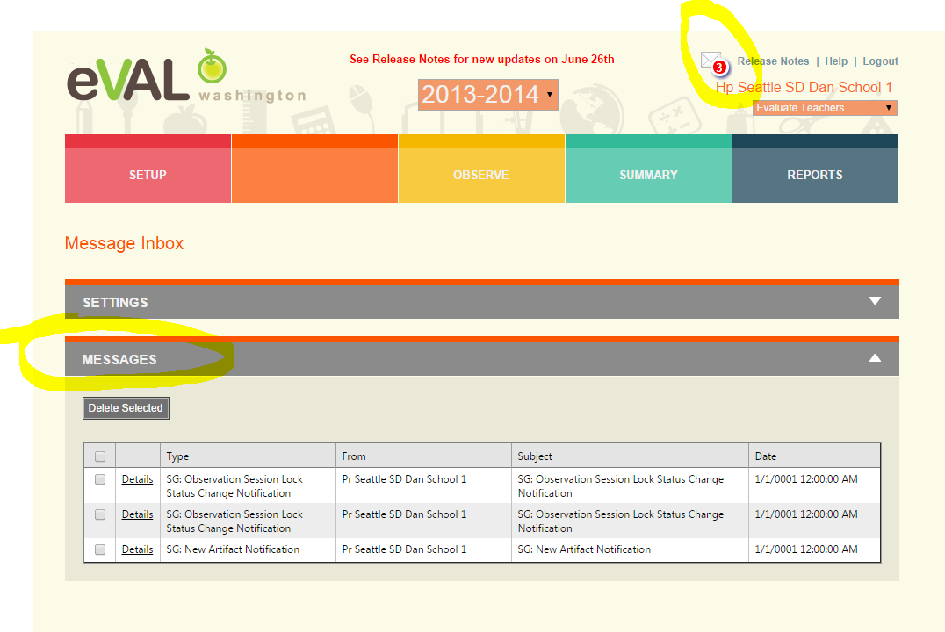

**ILLUSTRATION FOR 1.3**

The illustration below shows the check box that should default to “checked” for each District school in eVal

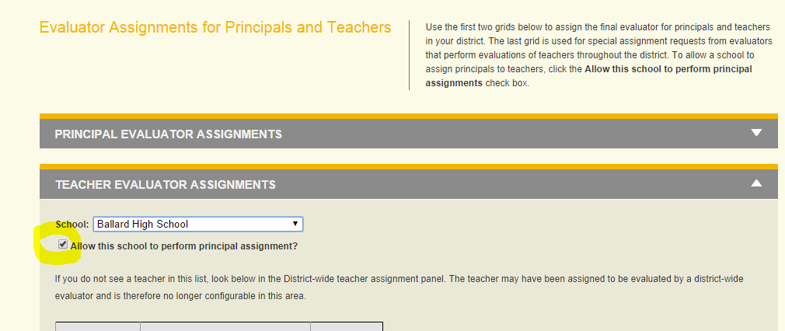

**ILLUSTRATION FOR 1.4**

The illustration below shows the current calendar function which too easily pre-sets a start time and which defaults to a 60 minute observation

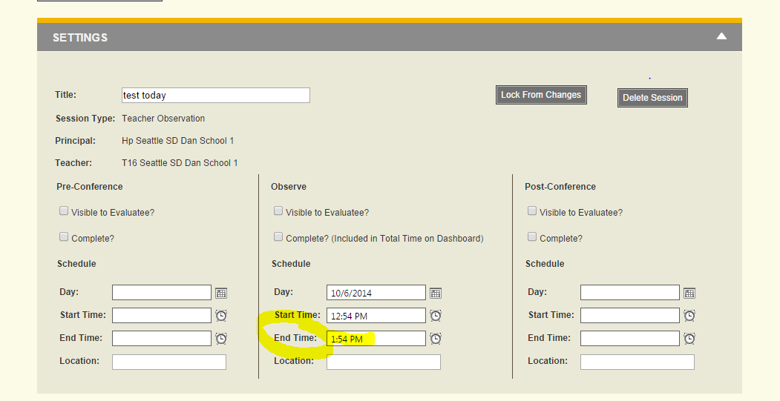

# Review and Approval

|  |  |  |  |  |
| --- | --- | --- | --- | --- |
| Team | Person | Organizational and Project Roles | Role | Date review/approval received |
| Project | Clover Codd | Exec Director Strategic Plan & Partnerships; **Project Sponsor** | Approve project deliverable | 11/5/14 |
| HR | Brent Jones | Asst Superintendent for Human Resources; Project Steering Committee representative for HR; Internal customer for many of the technology updates requested in these documents | Approve project deliverable | 11/19/14 |
| HR | Elaine Williams | Subject matter expert representing Labor Employee Relations Team | Review | 11/14/14 |
| HR | Denise Williams-Saunders | Subject matter expert representing Labor Employee Relations Team | Review | 11/14/14 |
| HR | Sue Means | Subject matter expert representing Labor Employee Relations Team | Review | 11/14/14 |
| DOTs | Nancy Petersen | Director, Enterprise Applications | Informational | 11/6/14 |
| DOTs | James Bradley | Manager, Business Applications | Informational | 11/6/14 |
| DOTs | Mabel Mah | Sr Business Analyst (SAP/HR); project systems analyst representing DOTs for design and development | Review and accept as milestone deliverable | 11/14/14 |
| eVal Dev Team | Anne Chinn | Lead eVal Developer | Review and accept as milestone deliverable | 11/7/14 |
| eVal Dev Team | Dana Anderson | eVal Supervisor/ Project Manager | Review and accept as milestone deliverable | 11/7/14 |